 | International Civil Aviation Organization  INFORMATION PAPER | METPWGMOG/7/IP/10  03/22/18

MEETING OF THE METEOROLOGY PANEL (METP)
WORKING GROUP MOG

SEVENTH MEETING

Frankfurt, Germany, 11 to 13 April 2018

Agenda Item | 3: Work required in support of WAFS Developments  3.3.31 Matters relating to the delivery mechanism of WAFS

NEXT GENERATION WAFS DELIVERY SYSTEM
(Presented by WAFC Washington)

SUMMARY
Upgrades to the current WAFS Data Delivery System are necessary in order to address future aviation needs. This paper documents the WAFC Washington’s proposal to upgrade the WIFS in order to address GANP requirements.

The Next Generation WIFS system will leverage the capabilities the FAA’s Common Support Services-Weather (CSS-Wx).

Action by the METP-WG/MOG is in paragraph 4.

  - The Global Air Navigation Plan (GANP) 2016 to 2030 defines modernization improvements to aviation services in the four general performance areas shown in figure 1.1 below. This paper presents a proposal that upgrades the U.S. WAFS Internet File System (WIFS), applicable to the Globally Interoperable Systems and Data performance area.
FIGURE 1.1 - GANP PERFORMANCE IMPROVEMENT AREAS
  - The GANP Interoperable Systems and Data performance area consists of the four modules (FICE, DATM, SWIM, AMET) shown in Figure 1.3 below. The proposed WIFS upgrades will support the System Wide Information Management (SWIM) and Advanced MET Information (AMET) modules of the Interoperable Systems and Data performance area.
  - SWIM is a technology enabler that provides the IT standards, infrastructure and governance necessary for systems to share information, improve interoperability, and reuse information and services. SWIM-compliant MET services make it possible to have access to real-time, relevant information so users can respond faster and more accurately.
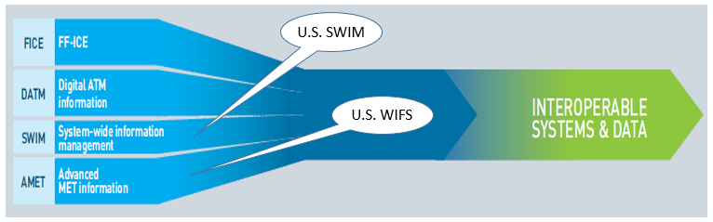
FIGURE 1.3 - INTEROPERABLE SYSTEMS AND DATA PERFORMANCE AREA MODULES
  - This paper provides some preliminary information on the characteristics of the next generation WIFS data delivery service.

- DISCUSSION
    - In order to meet the future needs of international air traffic defined in the GANP, improvements to the WIFS Delivery system are necessary. There have been tremendous advances in meteorological science and information technology since the advent of the WAFS, allowing for the production and distribution of higher quality, higher resolution weather data. One proposal is to increase the horizontal resolution of WAFC-produced gridded data from 1.25 to 0.25-degrees, as well as increase vertical and temporal resolution. Access to these data will allow users to take advantage of these advances and provide better planning information in pre-flight, daily flow, and tactical flow decision time frames.
    - The current WIFS Interface Control Document (ICD) defines concatenated ASCII and GRIB data structures that can only be downloaded as complete files. The ability to request a subset of these data files in order to save bandwidth is not currently supported. As an example, WIFS consumers cannot request temperature and winds for specific hours, individual levels of interest, or a specific geographic location. Current Operational Meteorology (OPMET) data files are rolling (last five minutes, last 30 minutes, last hour, etc.). With the increase in volume due to the IWXXM OPMET requirement and higher Resolution model data, a new solution is needed.
NEXT GENERATION WAFS DELIVERY SYSTEM CHARACTERISTICS
  - The Next Generation WIFS data delivery system(s) will be SOA/SWIM compliant.
  - One alternative for the new WIFS system is hosting it as an extension of the FAA’s CSS-Wx system, which delivers key benefits such as tailored geospatial subscription capabilities and customized subscriptions. This would leverage the FAA’s existing investment, leading to a more efficient use of resources both for the FAA and its customers.
  - The CSS-Wx is currently under development and will be entering operations in 2019. WIFS is a natural extension of existing CSS-Wx capabilities for providing operational, filtered access to data.
  - The CSS-Wx system provides a publish/subscribe interface that will only send data or notifications of interest to the user. All data in the system may be filtered using GIS-based boundaries (bounding box, jet route(s), airport, FIR, etc.). The result would be a net reduction in bandwidth, compute power and data storage for both WIFS and the WIFS Users.
  - Careful consideration in the design of this interface is needed to facilitate backup capabilities between U.S. and U.K. WAFC Solutions.
IMPLEMENTATION TIMELINE
  - In order to meet the objectives set out by the GANP, the aim is for the new system to be in operation by November 2022.
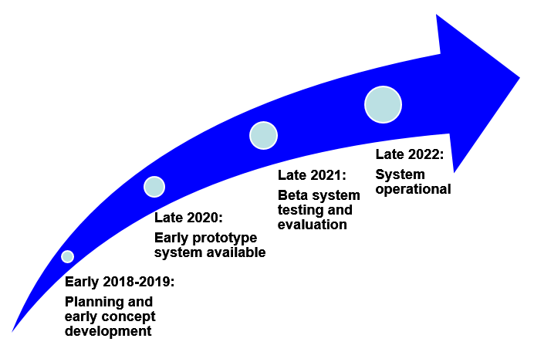

- Conclusion
  - Upgrades to the current WAFS Delivery System are forthcoming in order to address future air transportation needs. An upgrade to the WAFS Delivery System is required in order to meet these future needs. The Washington WAFC will collaboratively work with the ICAO MET community to refine current and future proposals relating to WIFS upgrades.
- ACTION BY THE METP-WG/MOG
  - The METP-WG/MOG is invited to discuss the following:
- Coordination of user workshops
- Potential harmonization between two WAFC’s
- Data retention/archiving
- Failover/backup scheme
- Data blending scheme
- Redundancy requirements/performance criteria

APPENDIX A
NEXT-GENERATION WIFS DELIVERY SYSTEM
System Characteristics
Figure A1 below shows a basic system architecture.
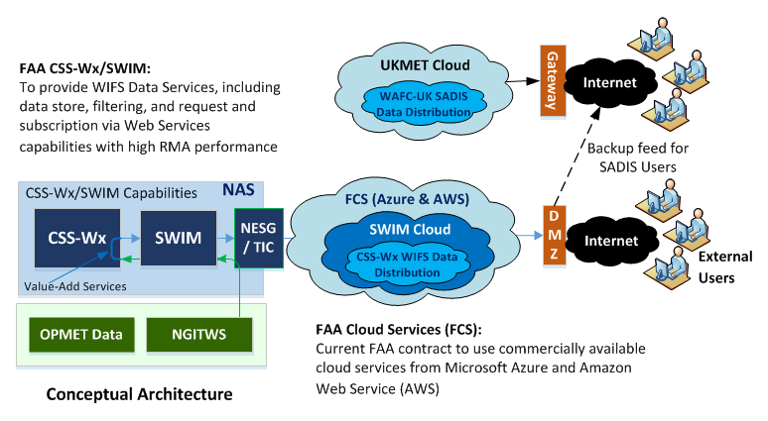
FIGURE A1 – CONCEPTUAL ARCHITECTURE FOR THE EXT GENERATION SWIM COMPATIBLE WIFS DATA SERVICE
Data Store
The Data Store will contain gridded data sets and multiple time-step SIGWX “Objects” produced by both WAFCs as specified in Annex 3 and from 2022 in PANS-MET. The full range of OPMET data will also be available in IWXXM format.
Requesting Data
Two main types of data requests would be available:
- Request-Response: Users’ systems will request data via standard geospatial web services

- Publish-Subscribe Messaging: a form of asynchronous service-to-service communication used where any message published to a topic is immediately received by all of the subscribers to the topic.

Output formats
Gridded Data Sets: GRIB-II Format (potentially offered in NetCDF-4 format)
SIGWX/OPMET: IWXXM XML Format
Example: A flight from New York to London
Waypoints: (-73.65, 40.78, ground level @ 0Z), (-54.66, 48.75, FL400 @ 1:13Z) (-17.66, 53.17, FL400 @ 03:49Z) (-8.52, 52.42, FL370 @ 05:20Z)
Products: Icing hazards
As new icing data arrives along the route of flight, the subset of data of interest to the consumer is sent to the subscriber. Data along the flight route is returned as segments with appropriate data being used on each segment of the flight.
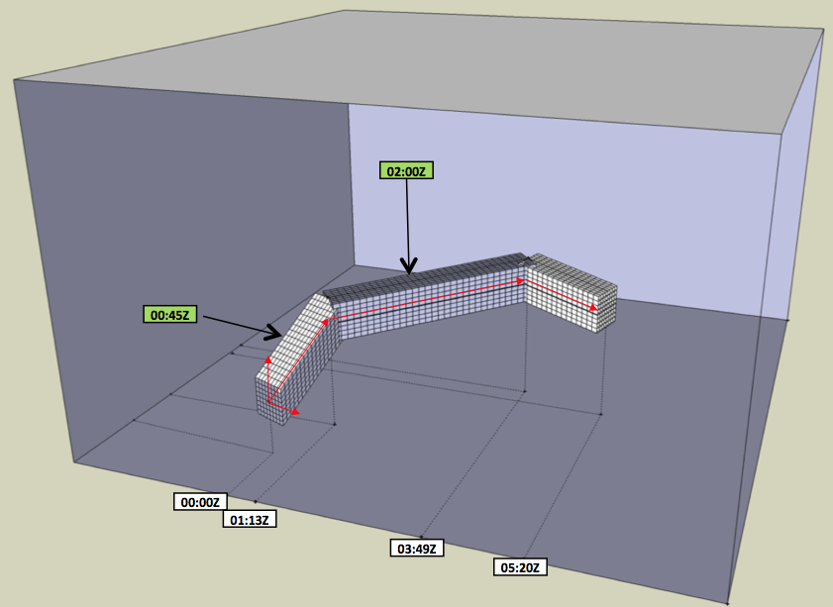
FIGURE A2 – FLIGHT EXAMPLE

Example: Notification of new gridded product time available
A WIFS consumer is interested in retrieving gridded winds data for a sizable area on the East Coast of the United States. The consumer subscribes for notifications on the availability of new GFS winds data files. As notifications are received, the consumer issues a Web Coverage Service request to retrieve the appropriate region of interest.
Example: WIFS consumer is sent METARs for a region of interest
A WIFS consumer is interested in receiving the METARs for (a region). The consumer subscribes to the WIFS system for all METARs within that area by supplying a Web Feature Service GetFeature request as the filtering component of the subscription. As METARs arrive they are sent directly to the consumer.

